**7-2 Project Two Submission**

Christian J. Kesler

Department of Computer Science, Southern New Hampshire University

CS-340: Client/Server Development

Professor Jeff H. Sanford

October 17, 2021

**README**

**Documenting the Project**

This project required that the animals database be presented as an interactive data table. This requirement is met in that the animals database is listed in its entirety upon loading the dashboard, and that selected cells respond by becoming highlighted when clicked on. The geolocation chart dynamically responds to the table as filters are applied, as does the pie chart that breaks down breed percentages. The top of the table has a series of buttons that allow for filters to be applied. Grazioso Salvare provided a list of prerequisites for dogs best suited for water rescue, mountain rescue, etc. Those prerequisites were combined in these filters so that only viable candidates are displayed. This can be seen in the following screenshots.

Here we can see my name and the top of the Grazioso Salvare logo:

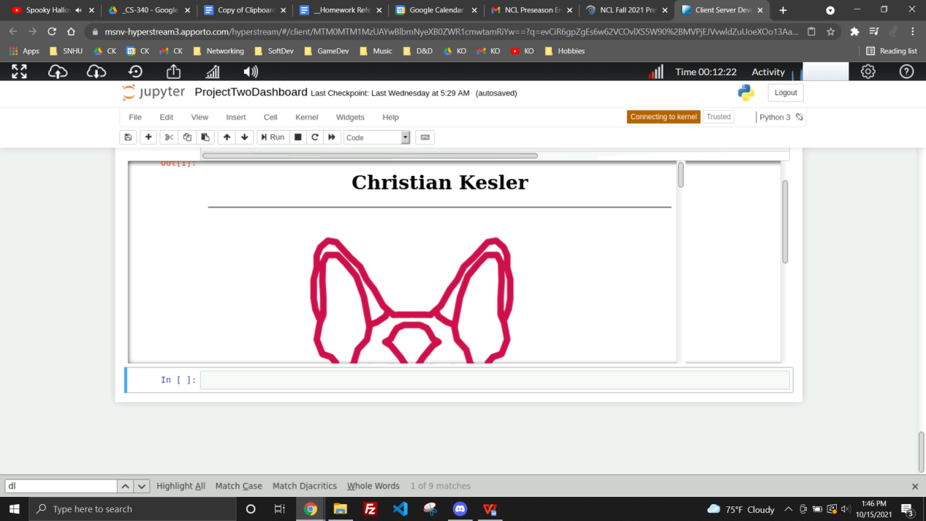

Here we can see the initial state of the charts, which reflects the state of the table:

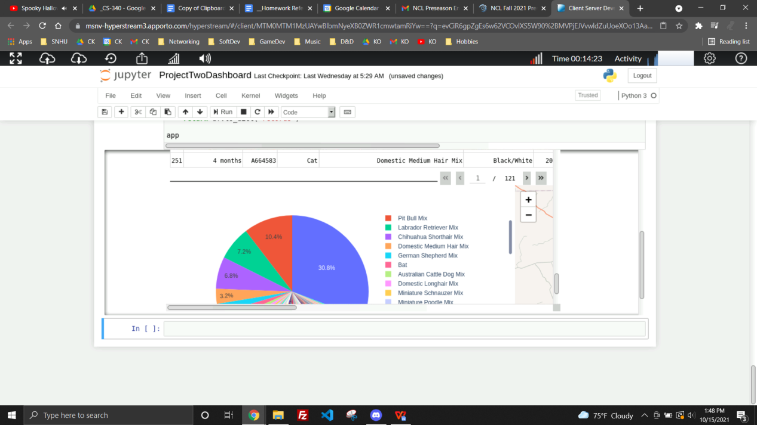

Here we can see the charts dynamically responding to the Water Rescue filter:

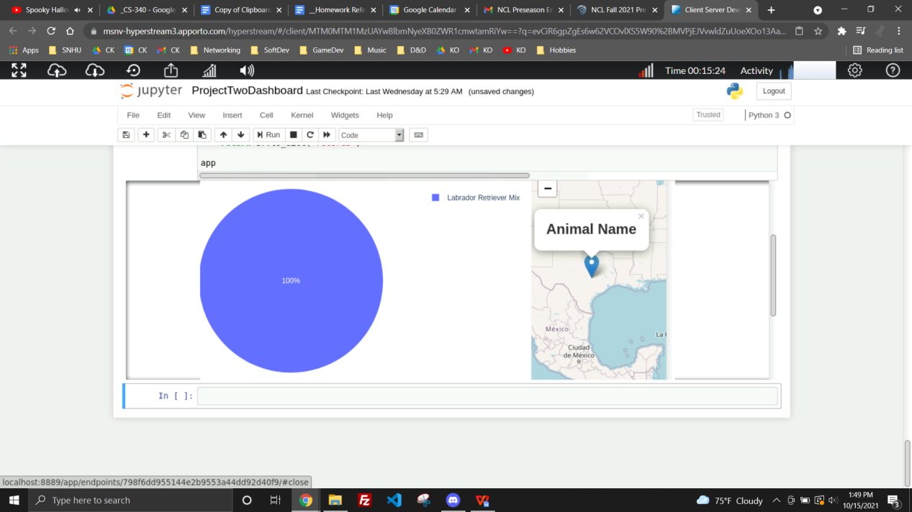

Here we can see the charts dynamically responding to the Mountain or Wilderness Rescue filter:

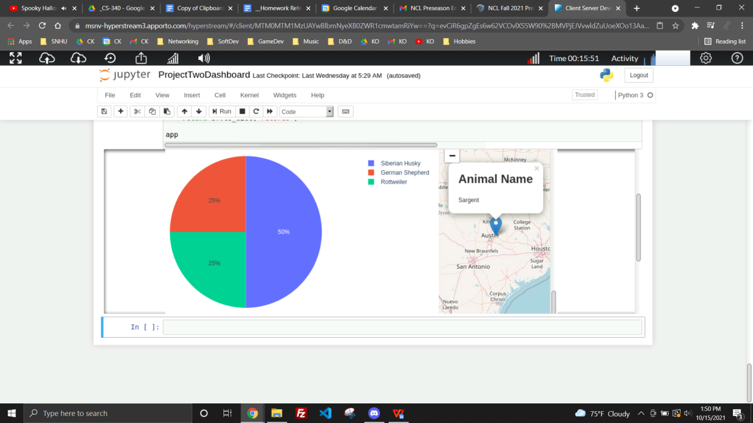

Here we can see the charts dynamically responding to the Disaster or Individual Tracking filter:

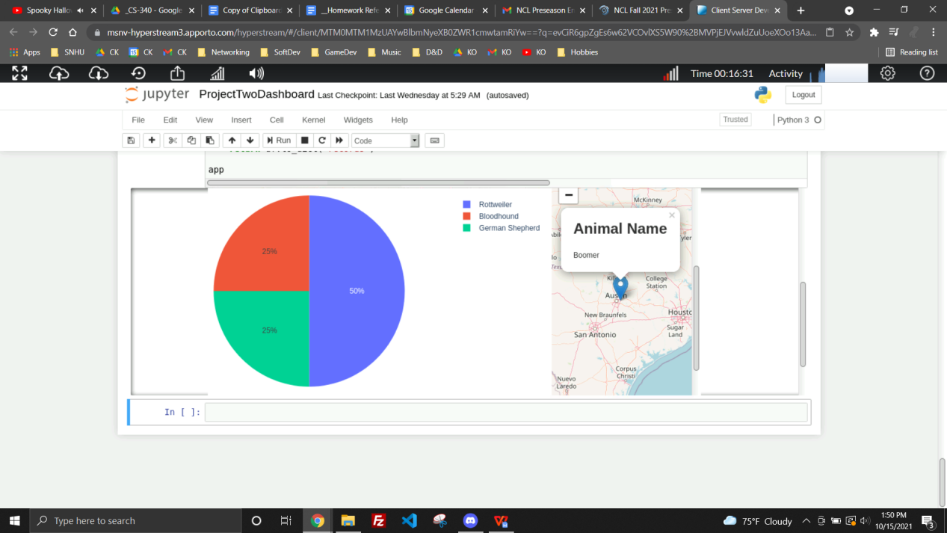

Here we can see the charts dynamically responding to the Reset filter:

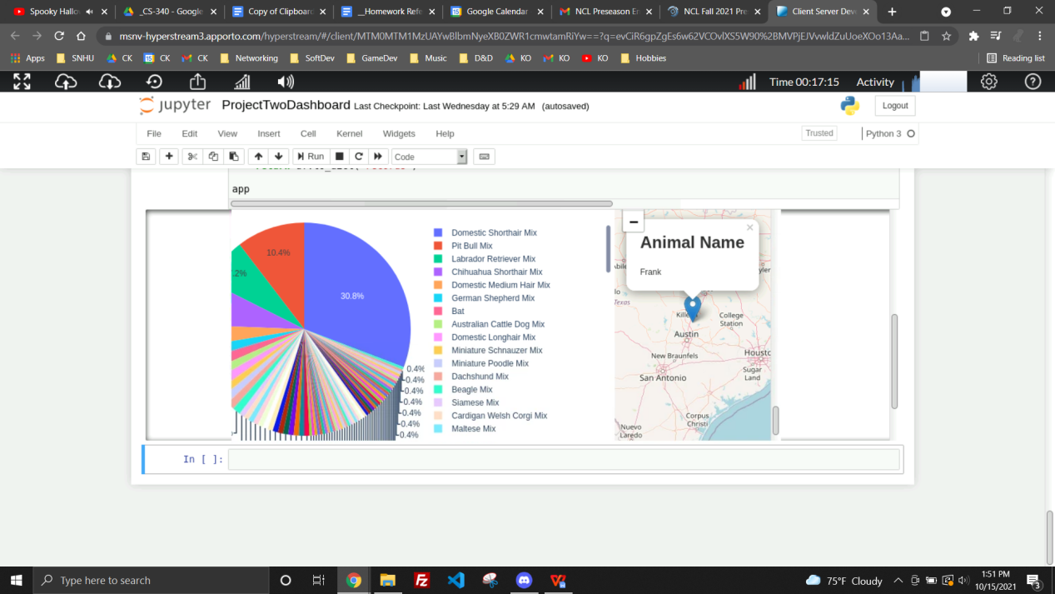

Mongodb was used to store the actual database entries since it is highly efficient and commonly used. Python was used to develop a CRUD module that interacts with the mongodb database since Python is among the most versatile languages. Mongodb is also easy to interface with Python, making the two a nearly ideal pair. HTML was used to create the dashboard itself since HTML excels in that department. Dash Leaflet was used to create the geolocation chart since that is among the best options for creating that specific chart. Plotly Graph Objects was used to create the pie chart since it provides all the calculations needed and was recommended by course resources. The Dash framework was used to provide the view and controller structure for the web application. It does this by rendering HTML elements within Python code, allowing for a dashboard that is able to dynamically update without the need for Javascript.

**Reproduction Instructions**

This project was developed in milestones, with the first being the CRUD Python module. Following that, I built a small Dash framework that utilizes the CRUD module as a proof of concept. The final milestone is this project, utilizing the resource I had created and tested for something applicable. The greatest challenge with this project was unfamiliarity, but being determined and thorough when looking for information regarding the many new tools I implemented allowed me to overcome that hurdle. Making incremental progress and testing as you go is the surest way to tackle something you know nothing about head on.